**Linux Installation Guide**

Click on Oracle VM Virtual Box to start to access your virtual Machine

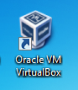

Select server to install DB and double click to start

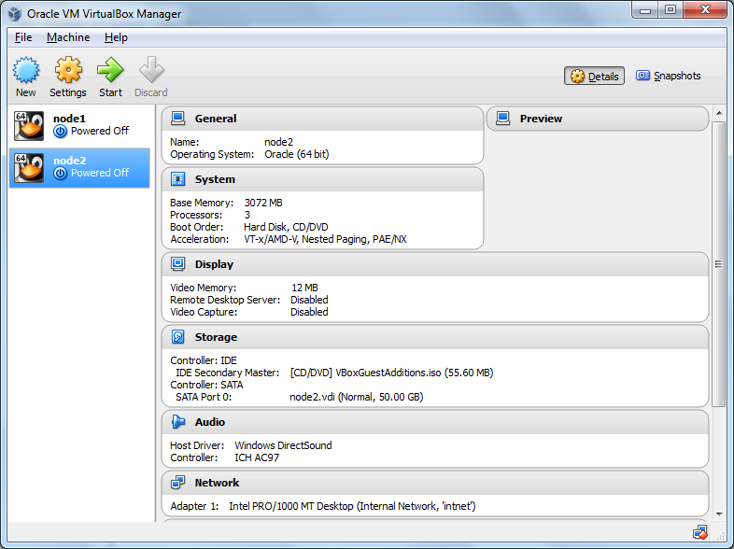

Click on New to create new virtual Machine on below screen

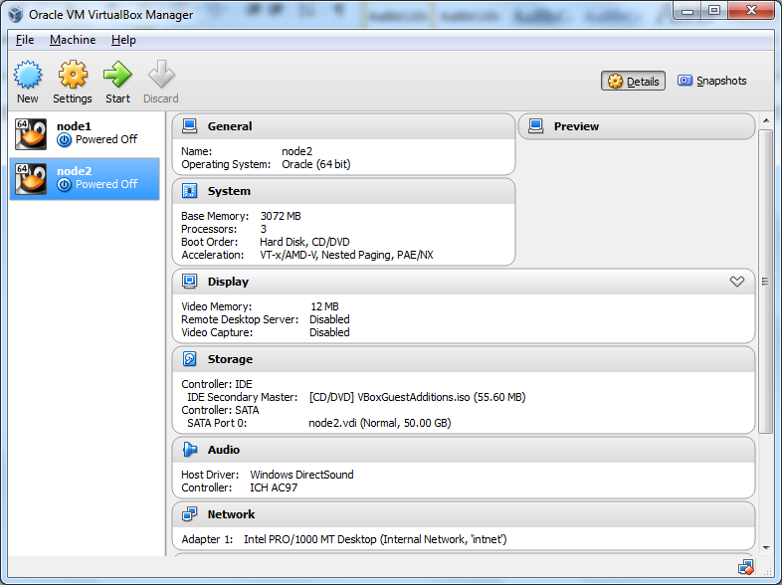

Enter desired Server name, Operating System and version for the same as mentioned below

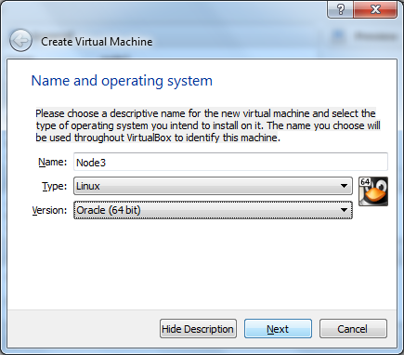

Allocate the desired RAM size for machine

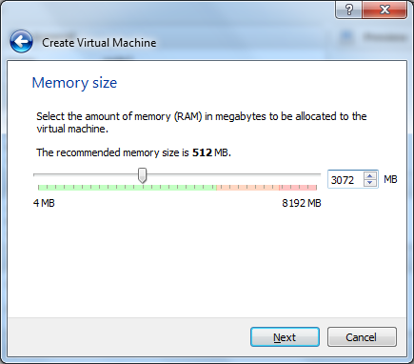

Select Virtual Hard Drive option as mentioned below and click on ‘Create’

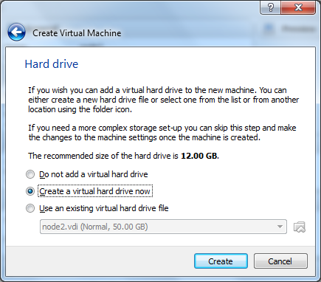

Select the hard drive type as VDI and click on ‘Next’

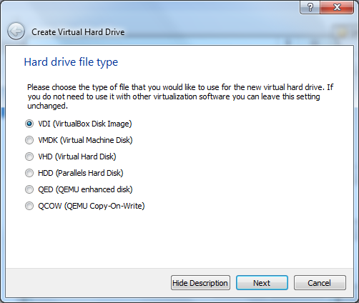

Select an option ‘Dynamically Allocated’ for storage on physical drive and click on ‘Next’

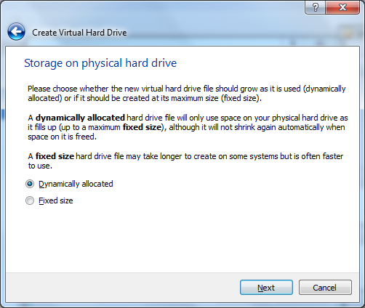

Click on to browse the desired location of to create the file in and select the required space on hard drive. Click on ‘Create’

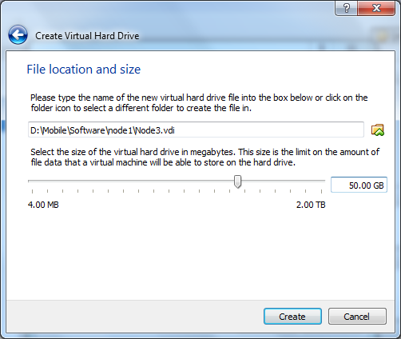

Now you should be able to view the machine created on Virtual box Manager Screen

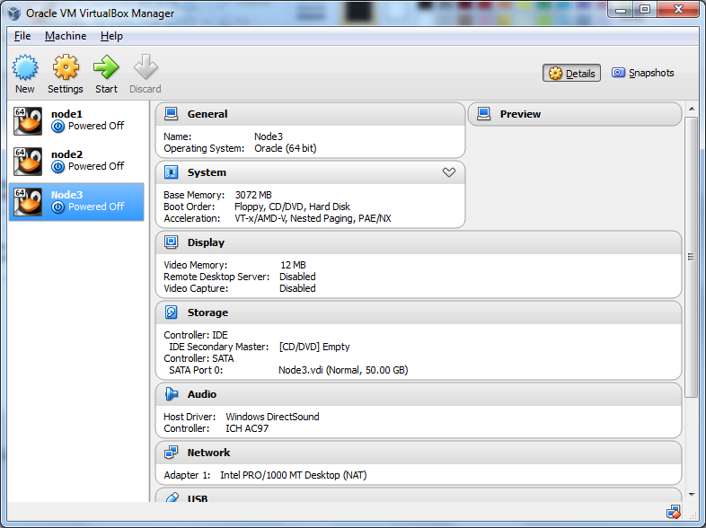

Right click on virtual machine and select settings

Select an option system to set boot order on motherboard as mentioned below

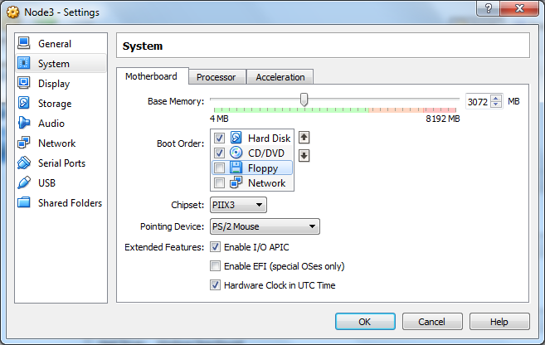

Under System select the next tab ‘Processor’ and allocate the required CPUs

1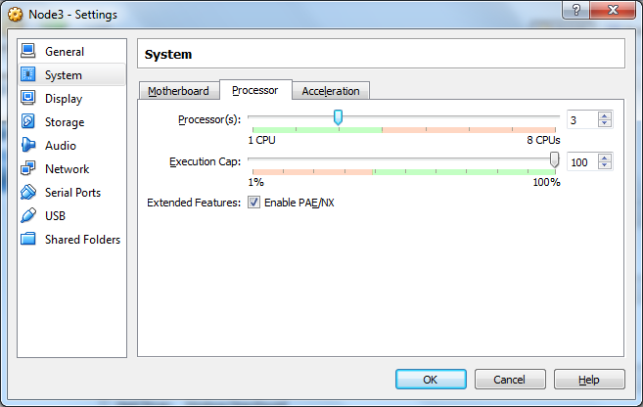

Select an option ‘Network’ on left grid and set values under ‘Adapter1’ as mentioned below

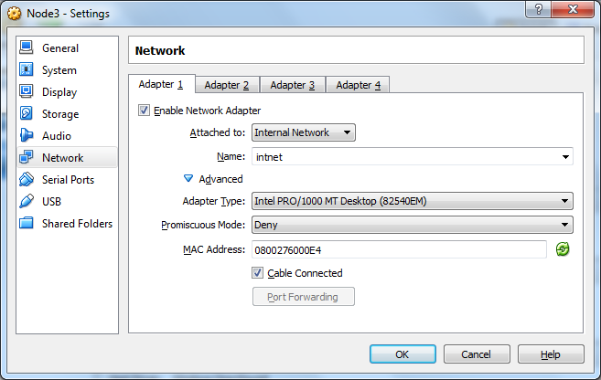

Select an option ‘Shared Folder’ on left grid

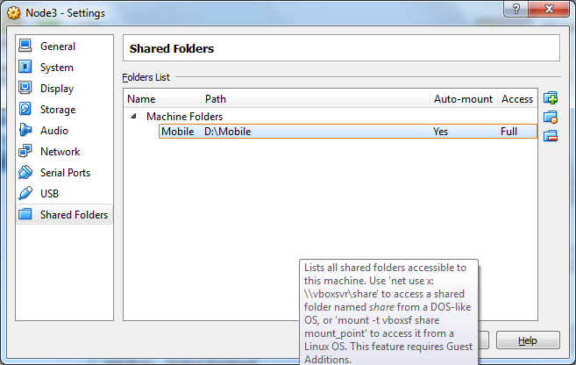

Click on icon to browse the location where software file is stored and click on ‘OK’

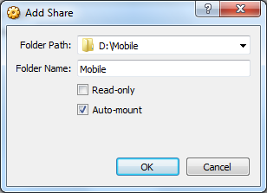

It is recommended to select an option ‘Auto Mount’

Now make sure that your machine is selected and click on ‘Start’

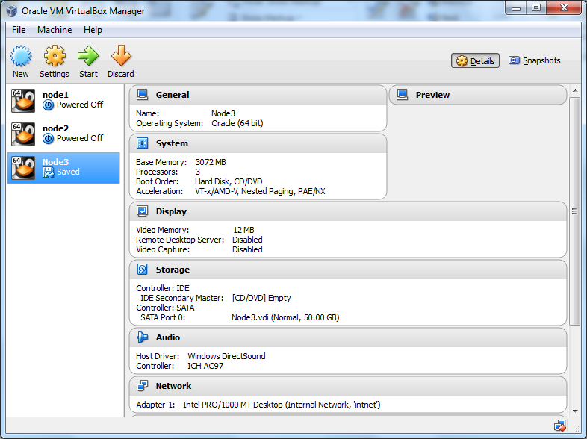

Browse and select startup disk image and click on ‘Start’

Select an option ‘Install or Upgrade an existing system’ and press ‘Enter’

On Next Screen click on ‘SKIP’

On below screen click on ‘Next’

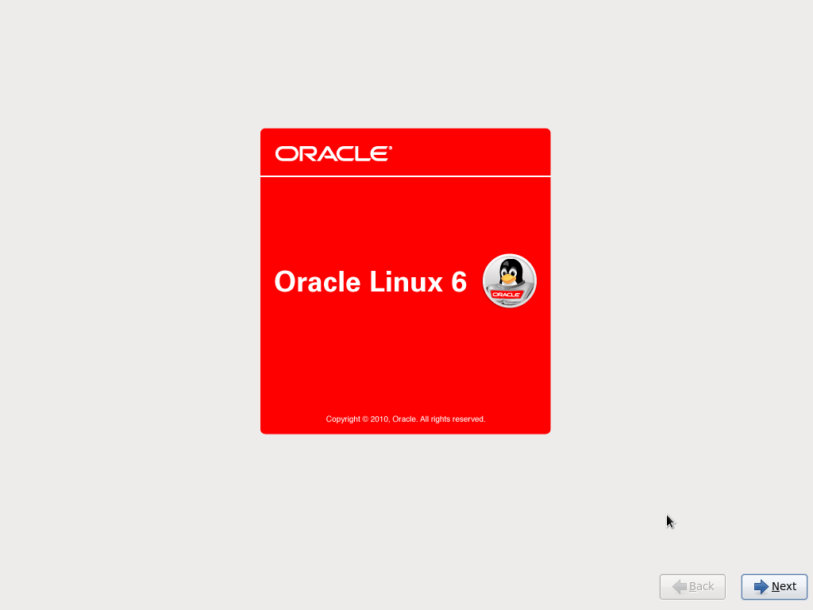

On next screen click ‘Next’

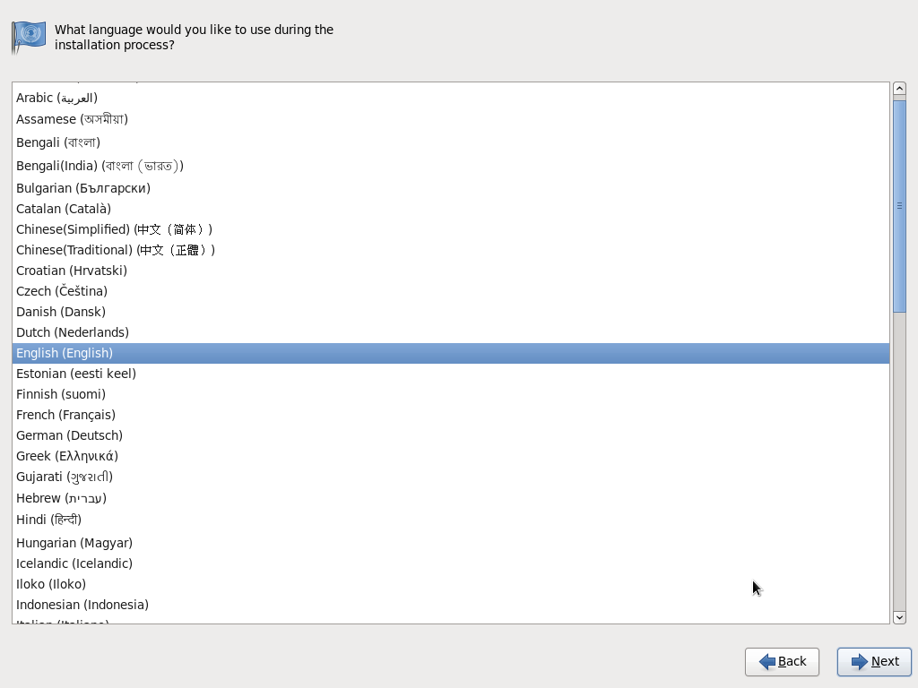

On next screen click ‘Next’

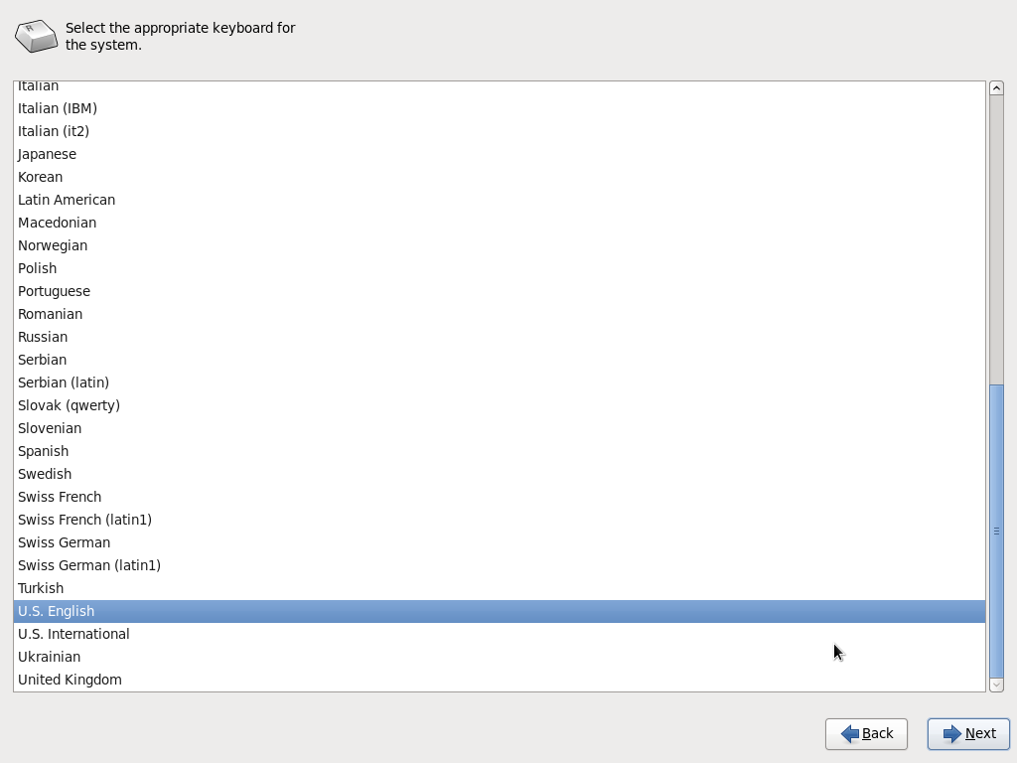

Select Basic storage Devices and click on ‘Next’

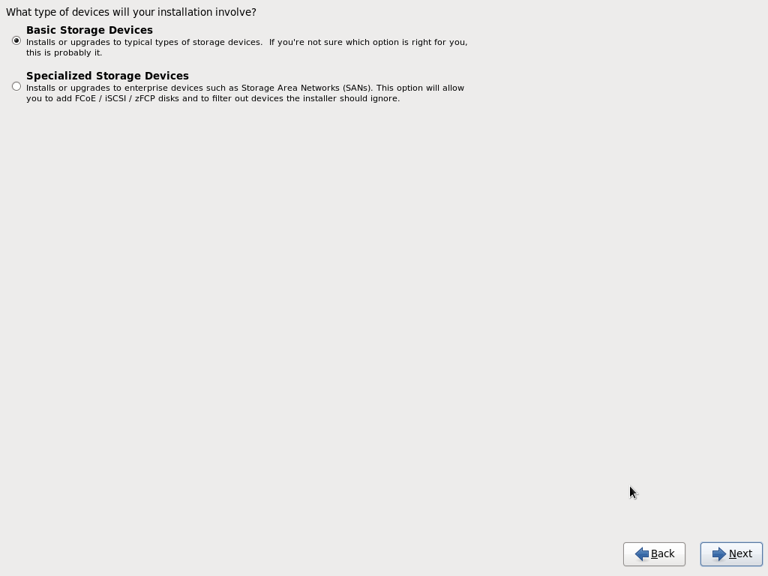

On pop up message select ‘yes, discard any data’

On next screen write hostname and click on ‘Configure Network’

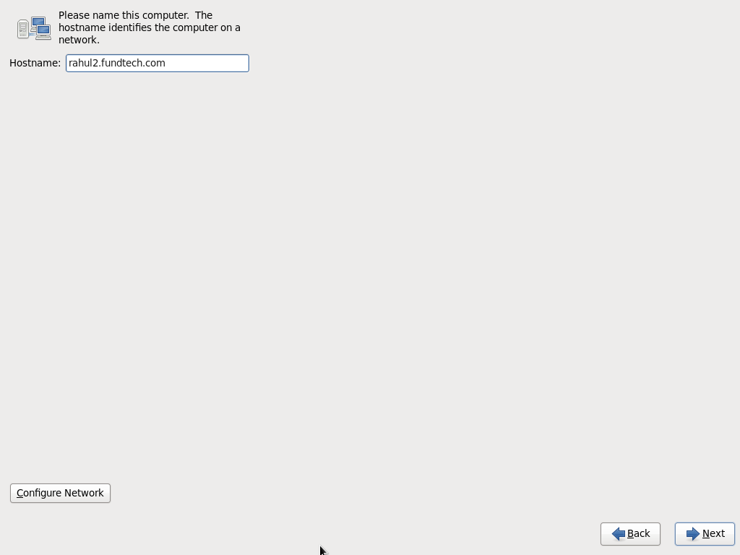

On popup window select ‘System eth0’ and click on ‘Edit’

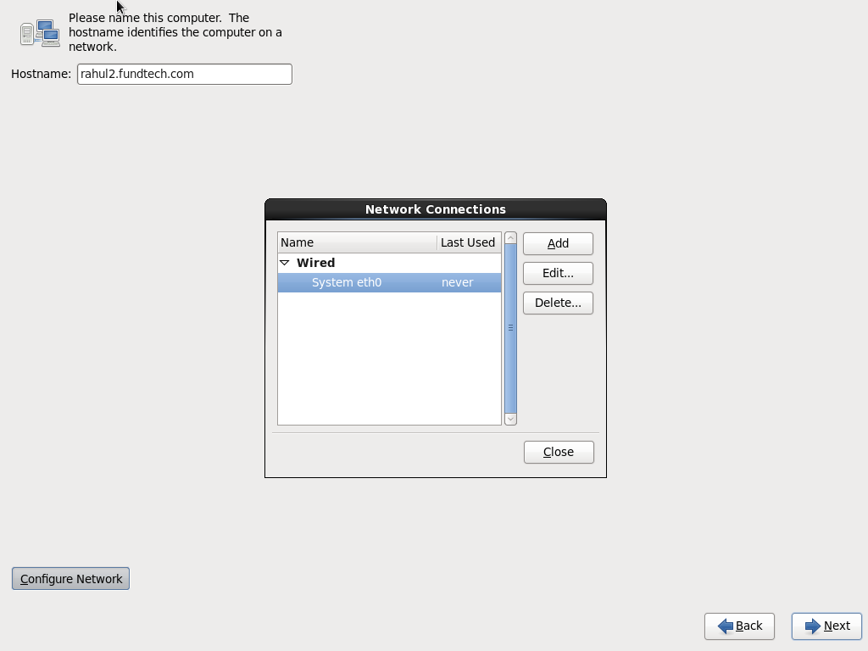

On next Popup window select an option ‘IPv4 settings’ then method as ‘manual’ from dropdown option and then click on ‘Add’ to enter details as mentioned below.

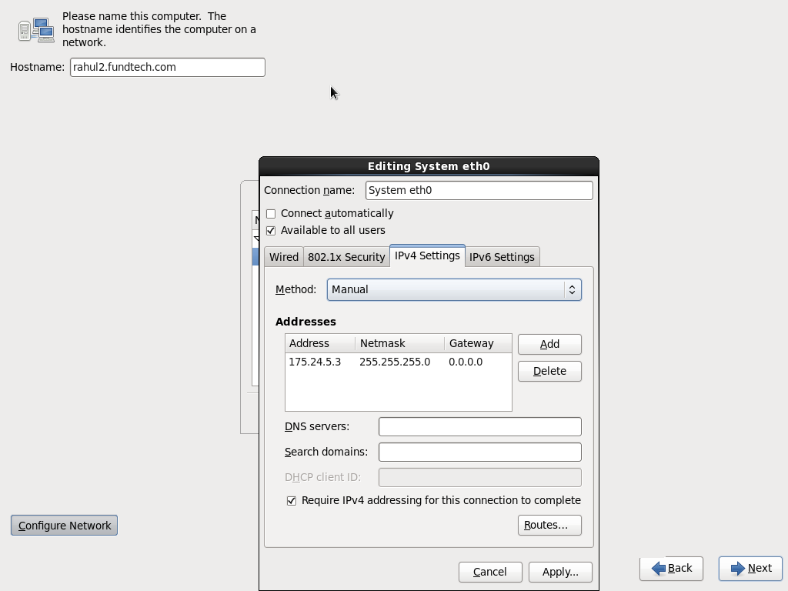

Click on ‘Apply’ and ‘Close’

Click on Next and select time zone as ‘Kolkata’. Click on ‘Next’

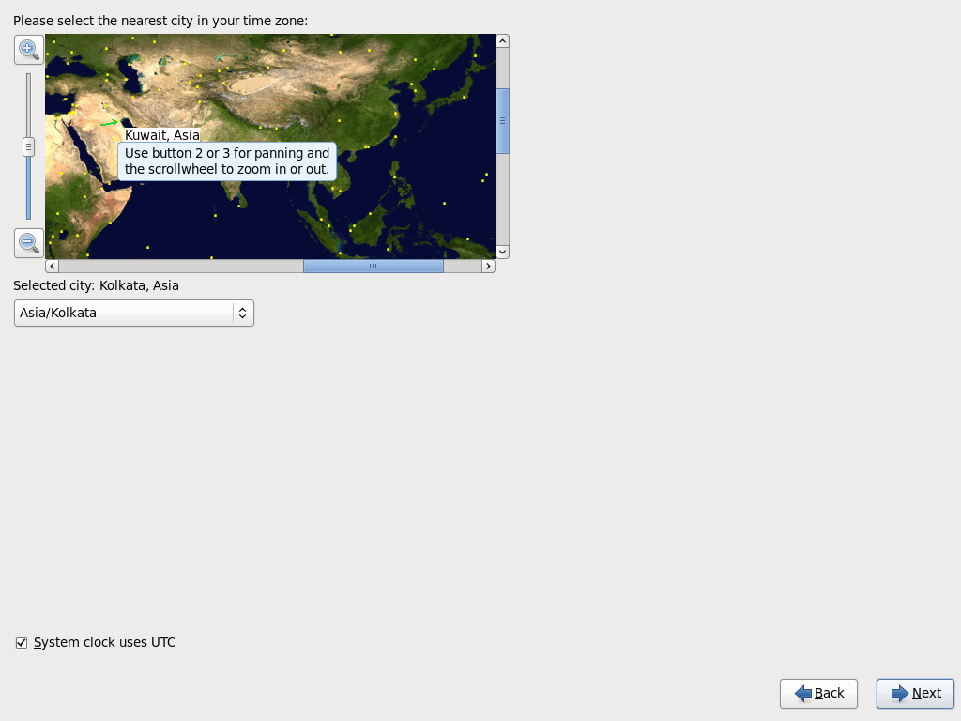

Enter Root password and confirm. Click on ‘Next’ (on pop up message click ‘Use anyway’ to move ahead

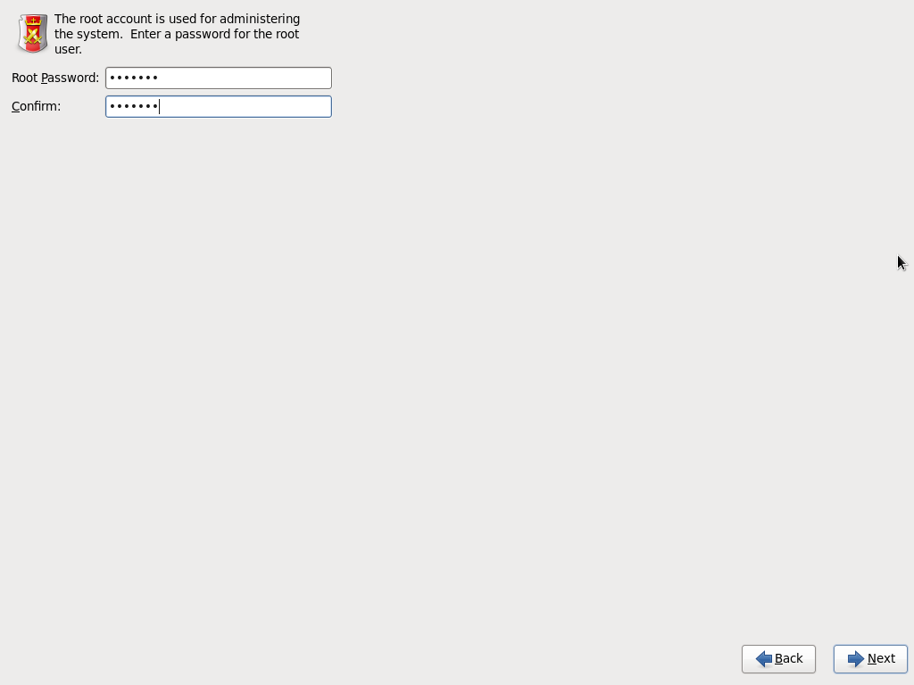

On next screen select ‘Create Custom Layout’ and click on ‘Next’

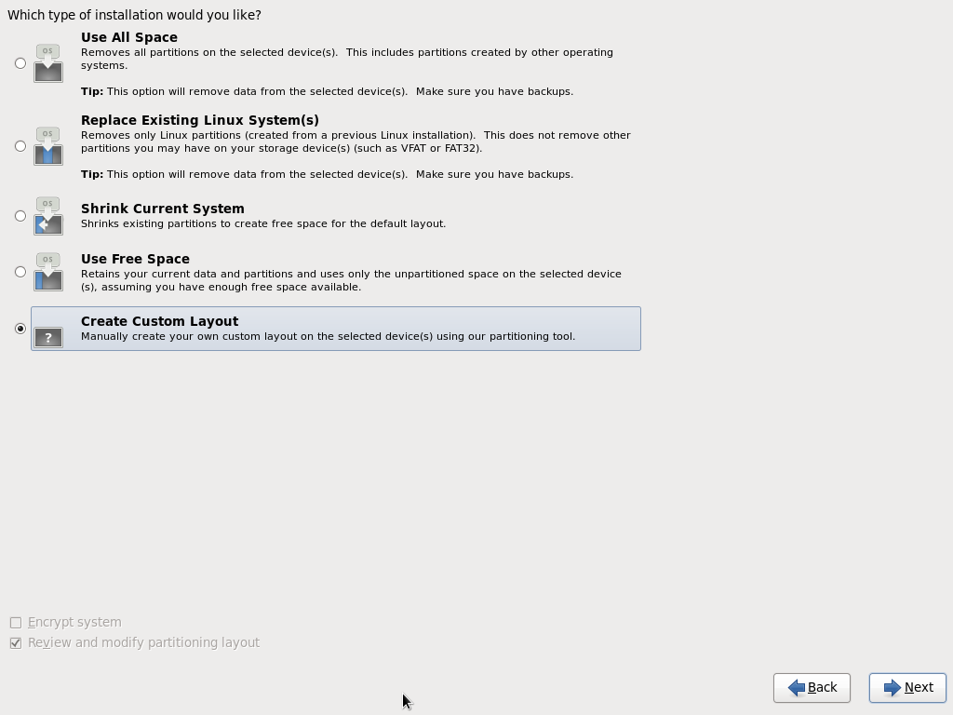

Select free memory space and click on ‘Create’

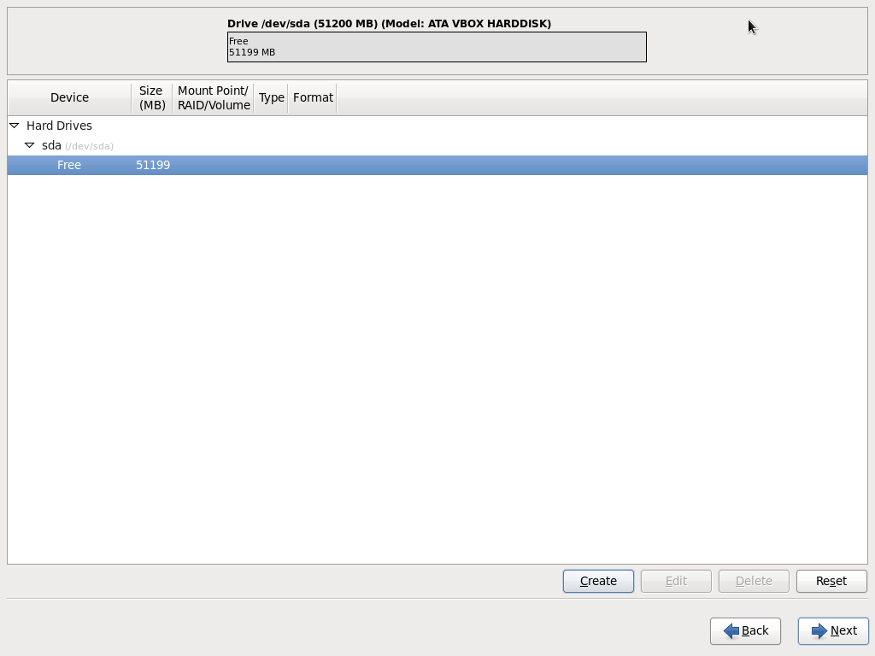

Select an option ‘Standard Partition’ and click on ‘Create’

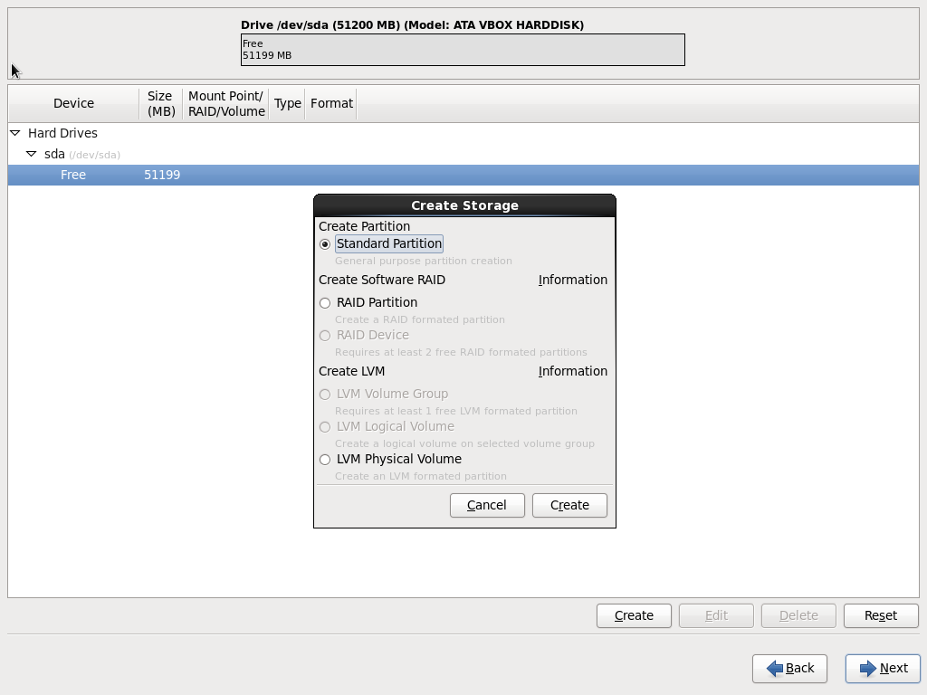

Select ‘File System type’ as ‘Swap’ and ‘Size’ and click on ‘Ok’

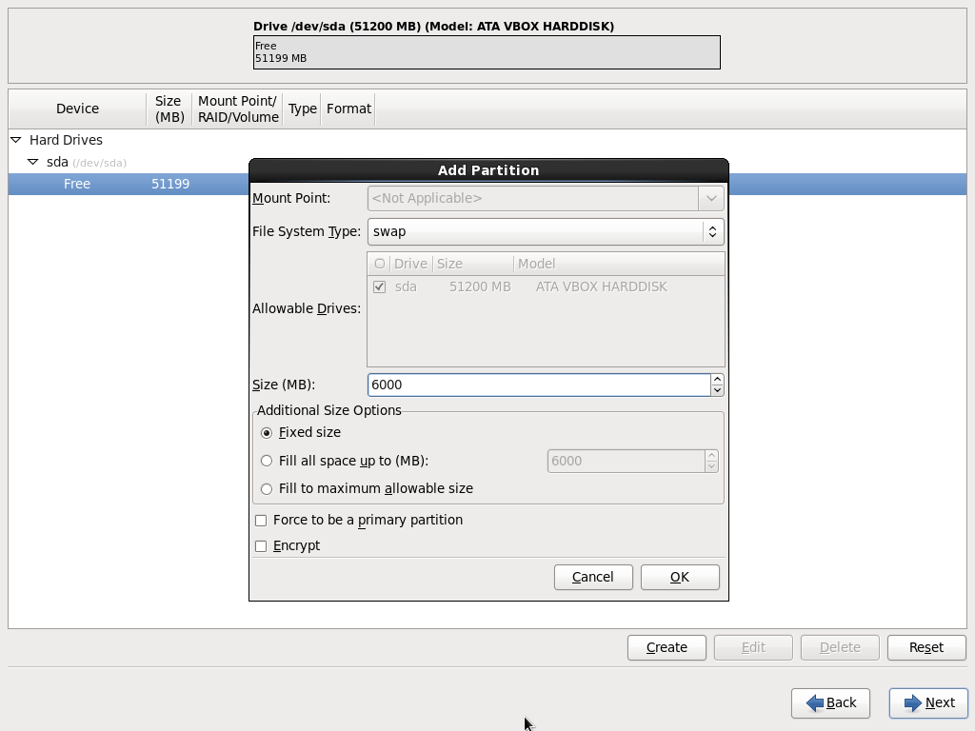

Select free memory space and click on ‘Create’



Select an option ‘Standard Partition’ and click on ‘Create’



Select ‘File System type’ as ‘/Boot’ and ‘Size’ and click on ‘Ok’

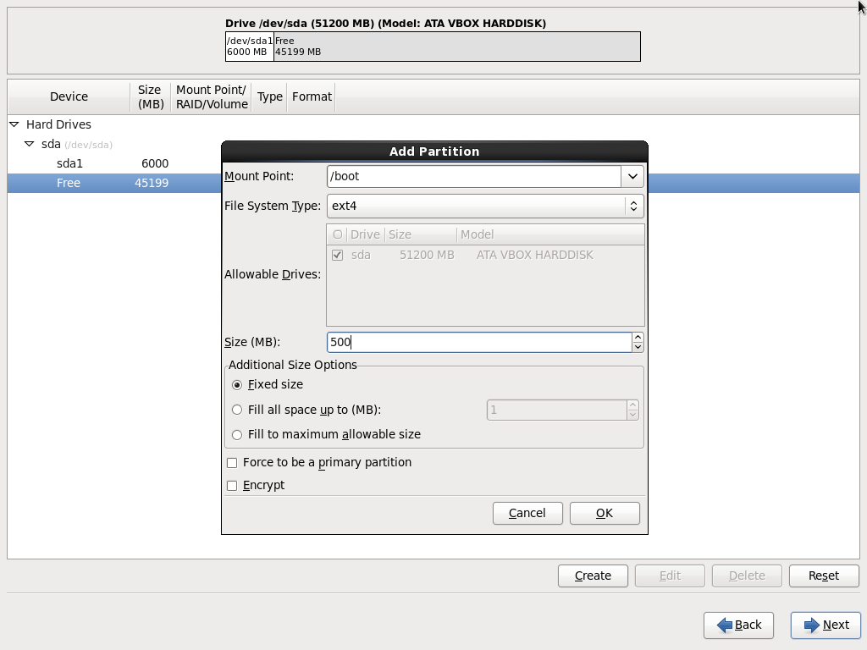

Select free memory space and click on ‘Create’



Select an option ‘Standard Partition’ and click on ‘Create’



Select ‘File System type’ as ‘/’ (root) and select tick box ‘Fill to maximum allowable size’. Click on ‘Ok’

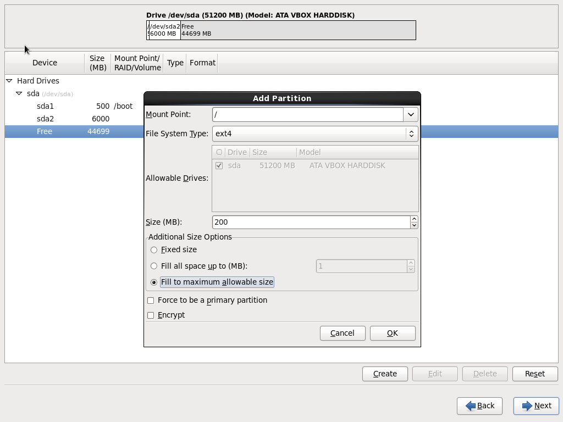

Click on ‘Next’ and ‘Format’ on Popup

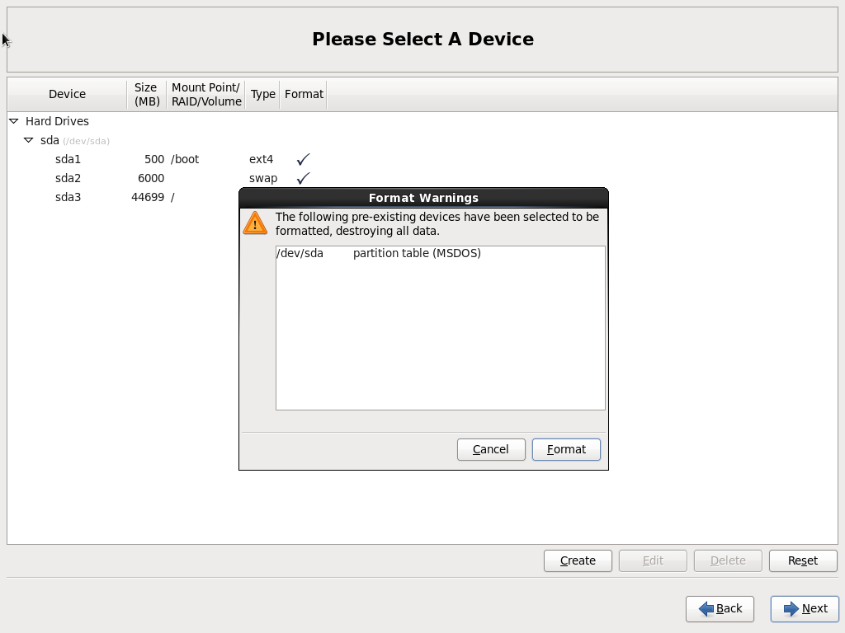

On Next popup click on ‘Write changes to disk’

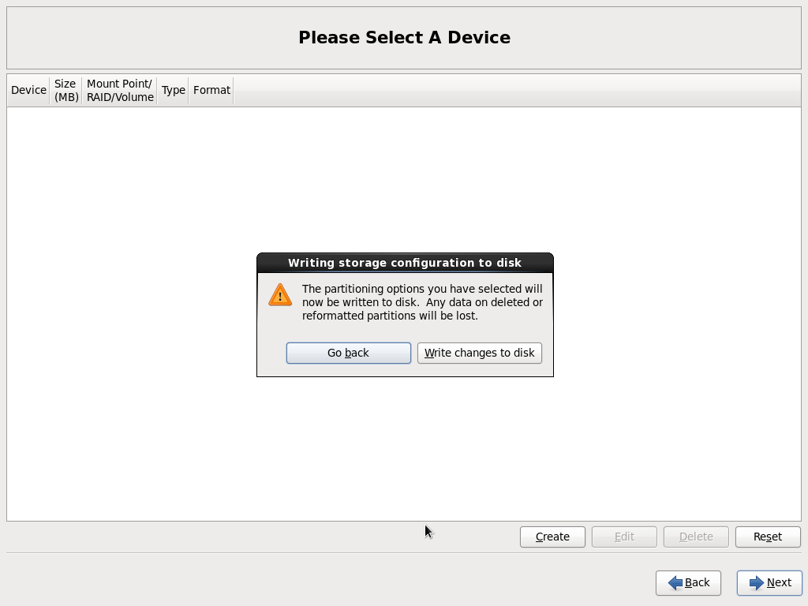

On Next window, click on ‘Next’

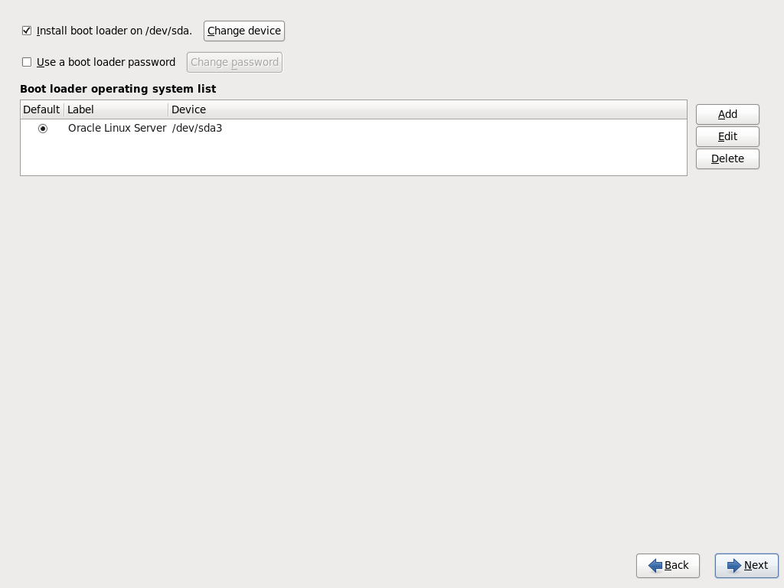

On next window select radio button ‘Customize Now’ and click on ‘Next’

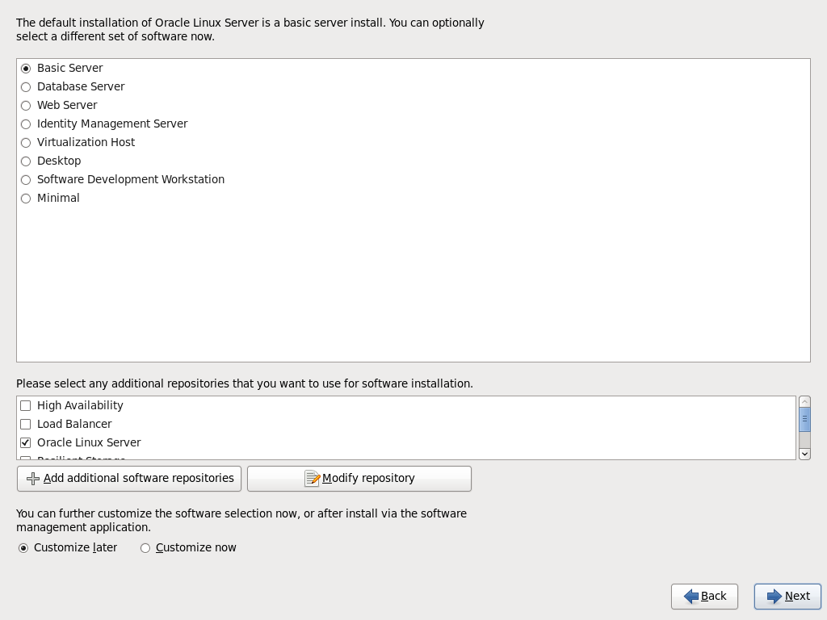

On left grid select ‘Servers’ and tick the options mentioned below

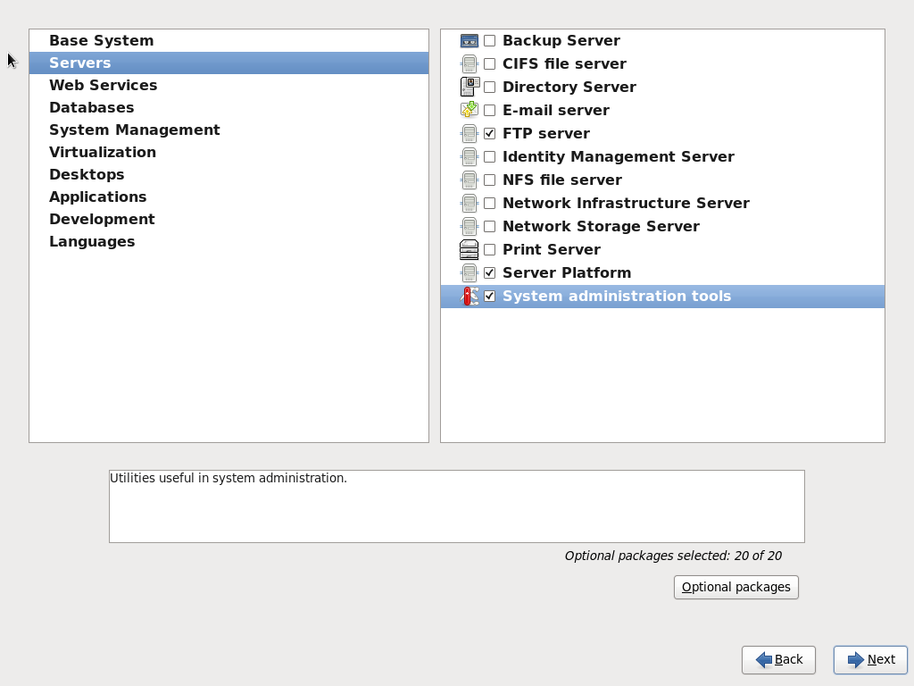

On left grid select ‘Web Services’ and tick the options mentioned below

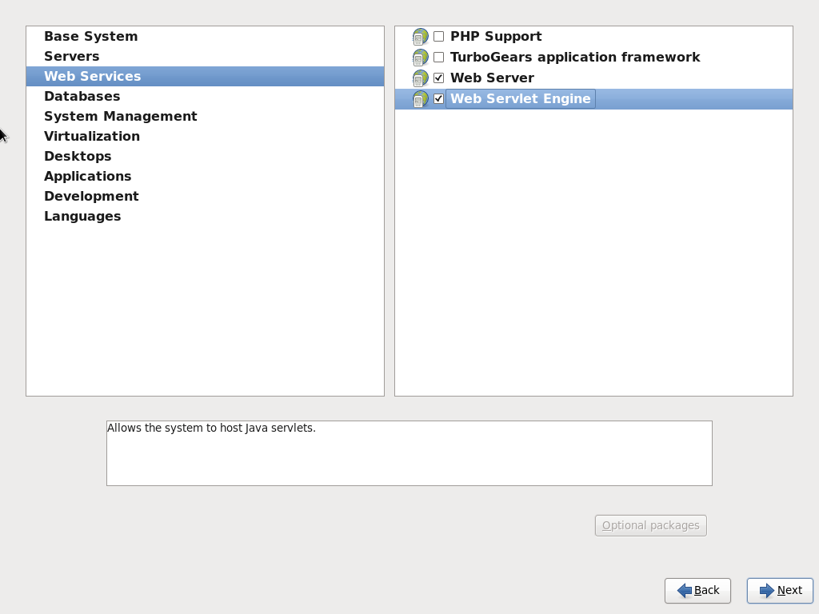

On left grid select ‘System Management’ and tick the options mentioned below

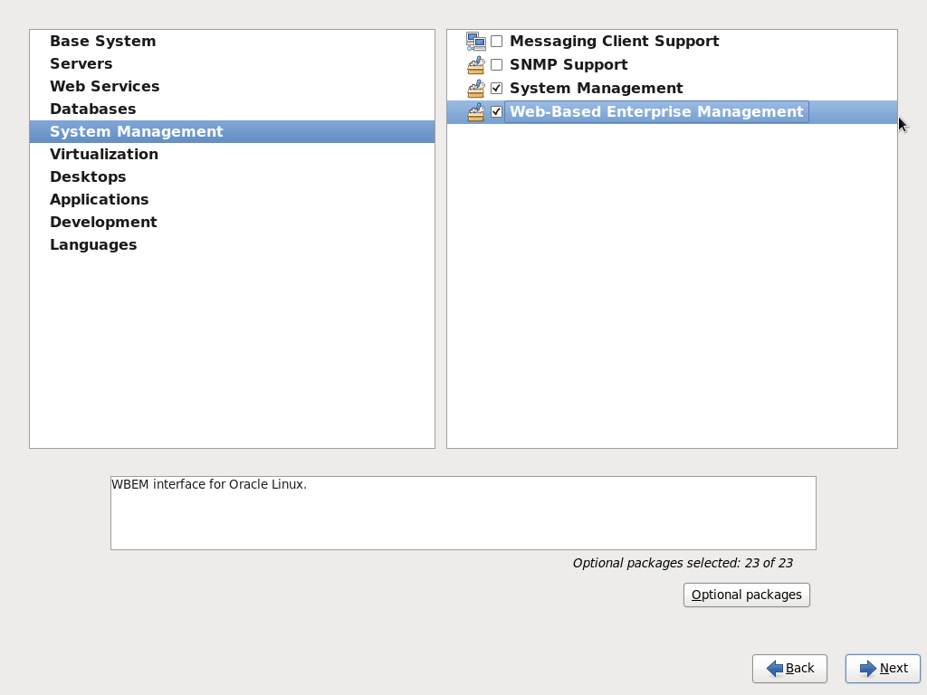

On left grid select ‘Desktops’ and tick the options mentioned below

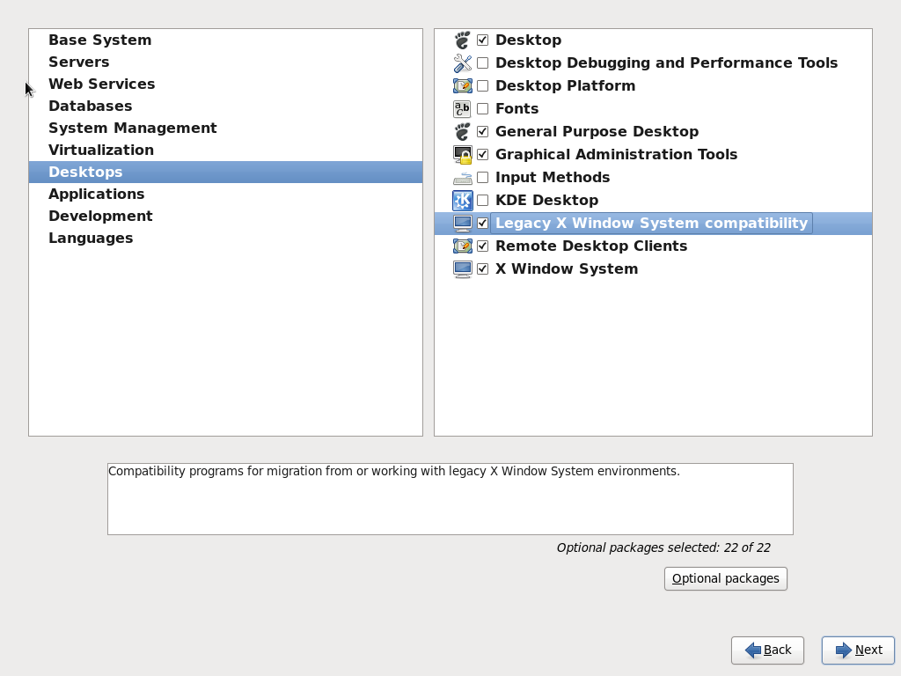

On left grid select’ Applications’ and tick the options mentioned below

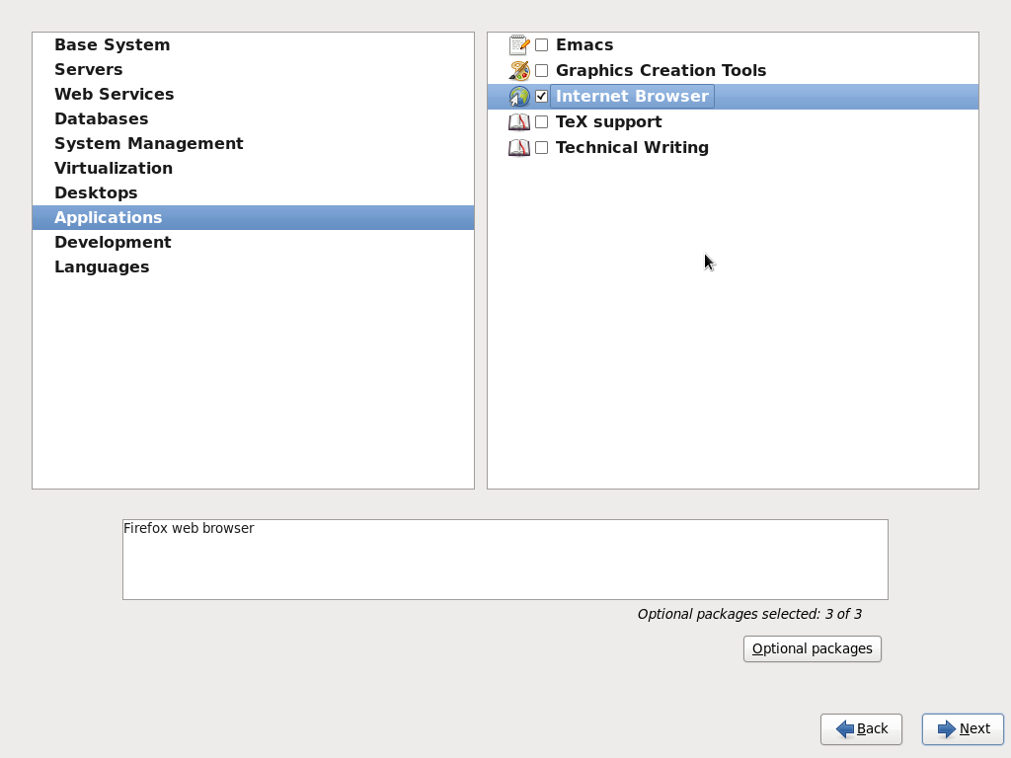

On left grid select Development and tick the options mentioned below Click on ‘Next’ to proceed ahead

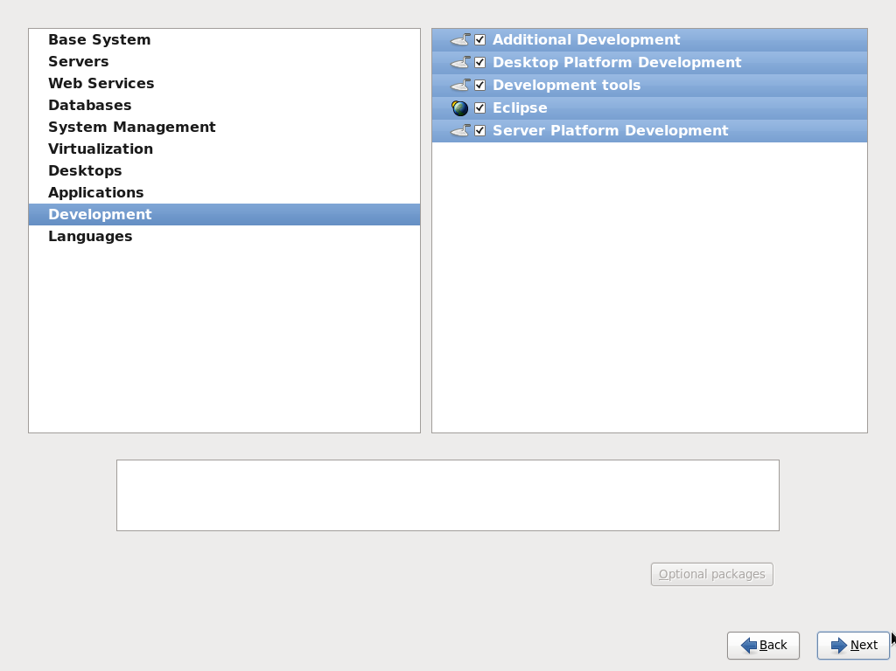

Click on ‘Reboot’

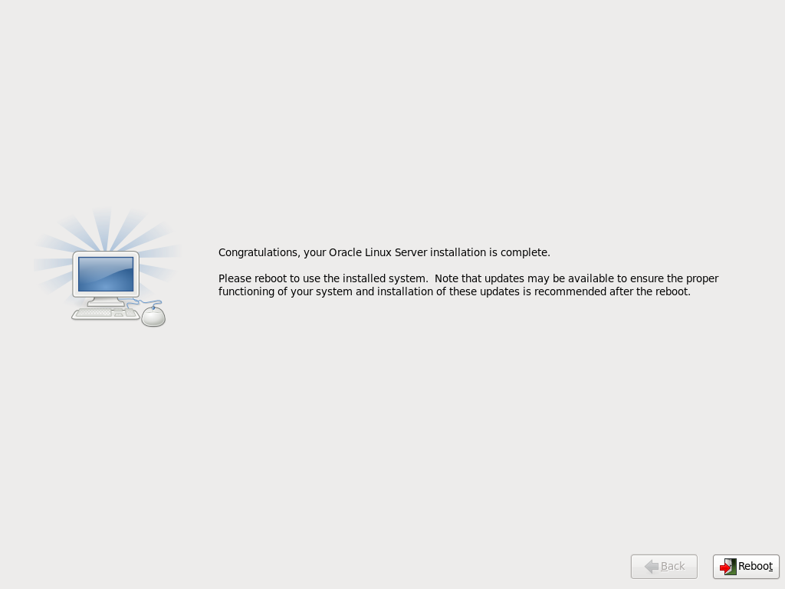

Click on ‘Forward’

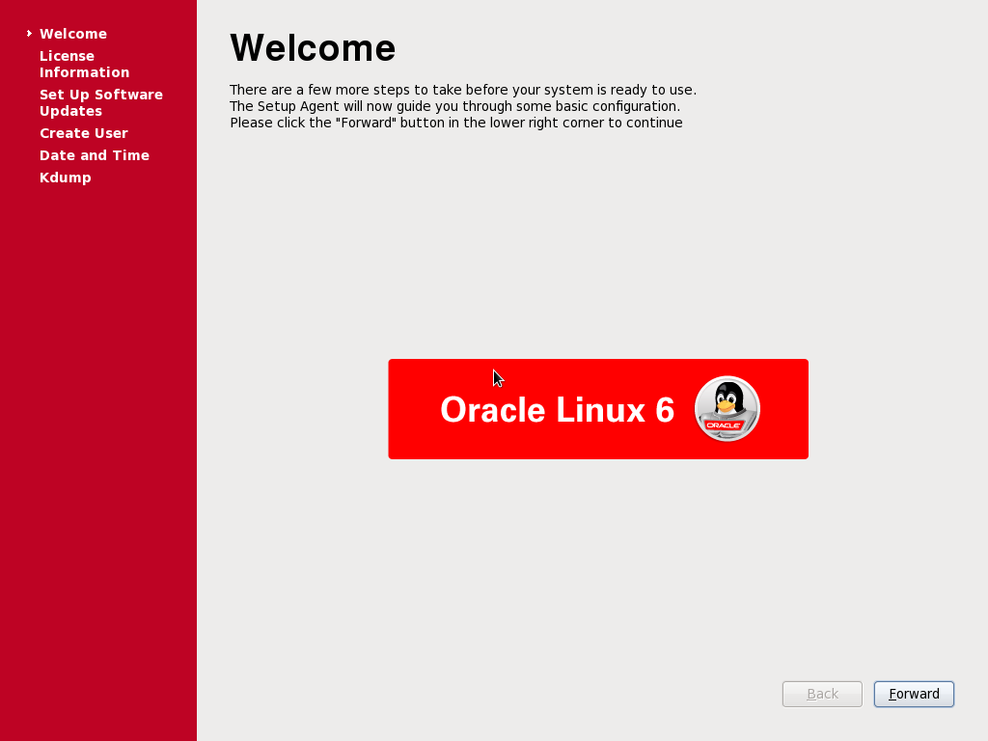

Click on ‘Forward’

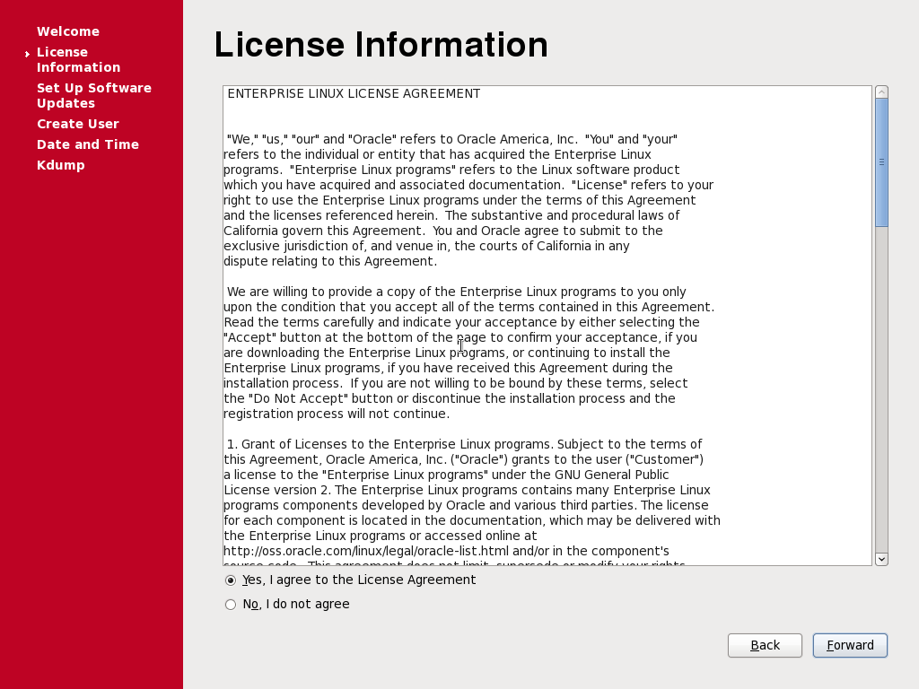

Click on ‘Forward’

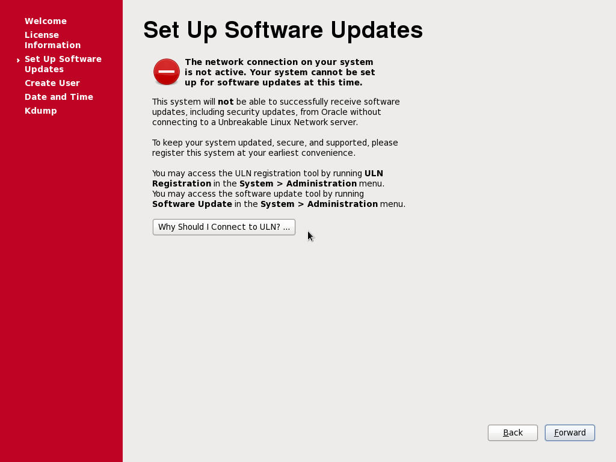

Click on ‘Forward’

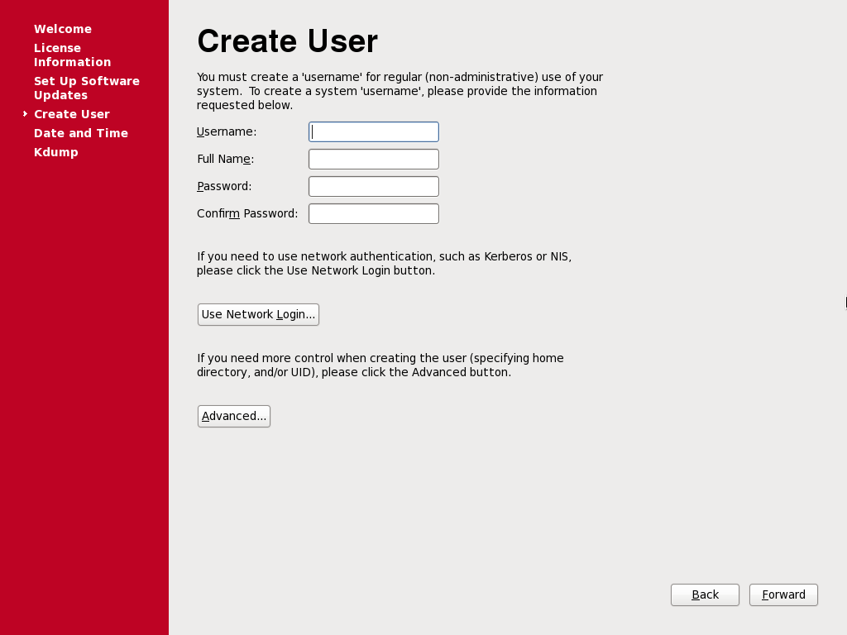

Click on ‘Forward’

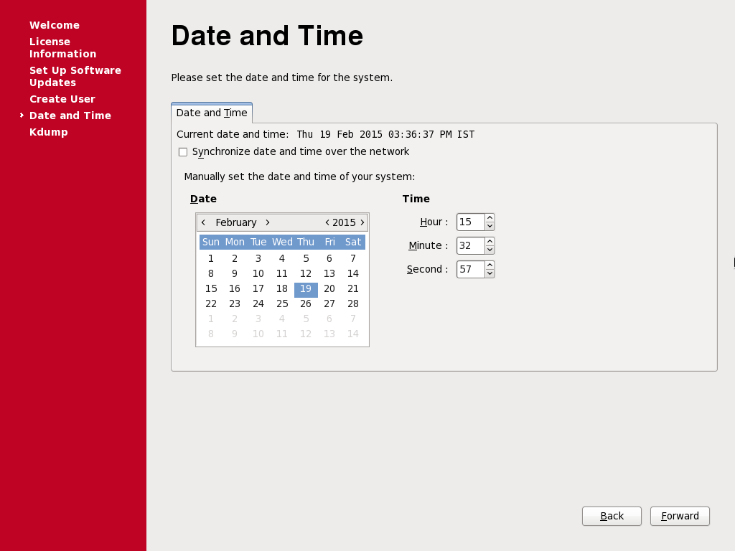

Click on ‘Finish’

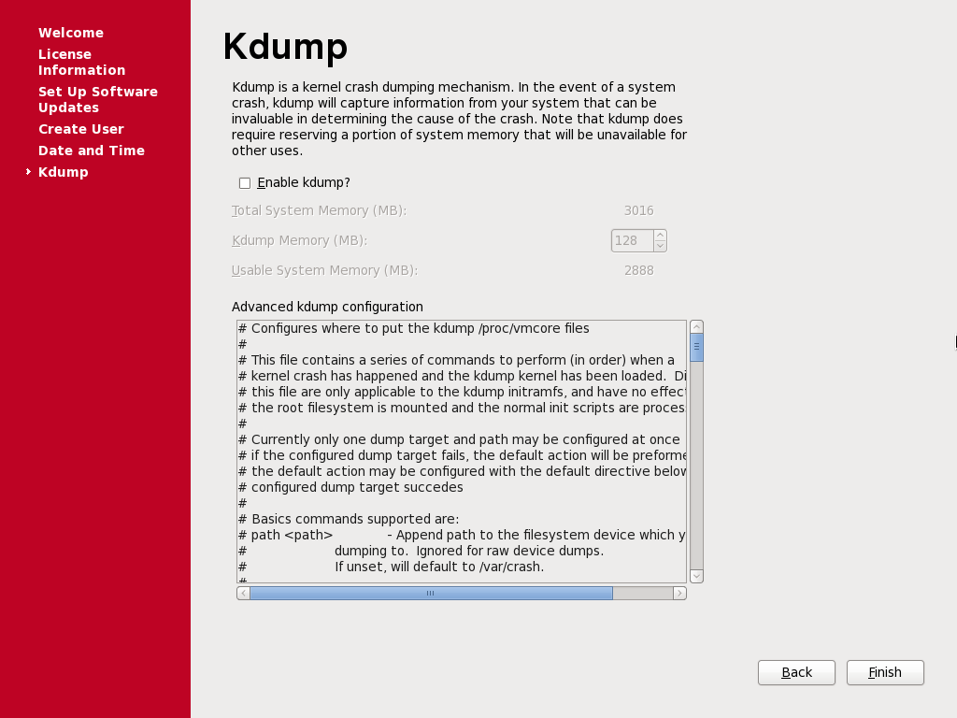

Select user option ‘other’

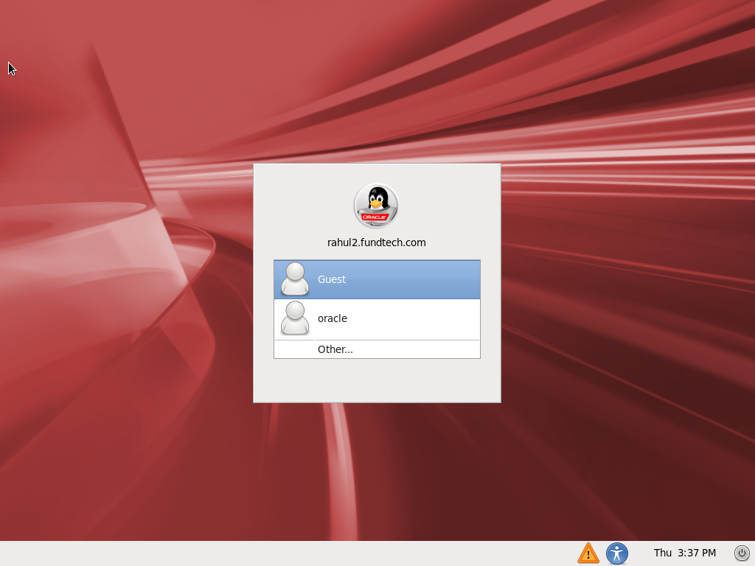

Enter username as ‘root’

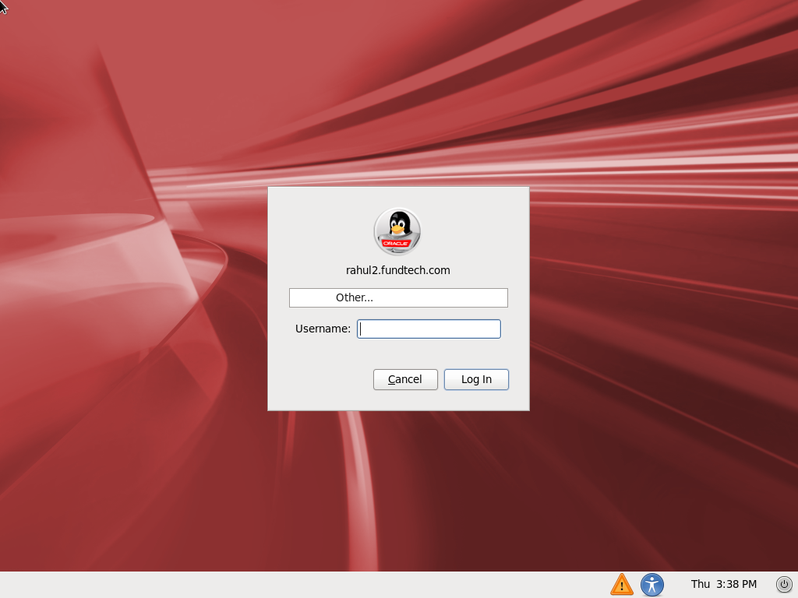

Enter the password set for root and press ‘Enter’

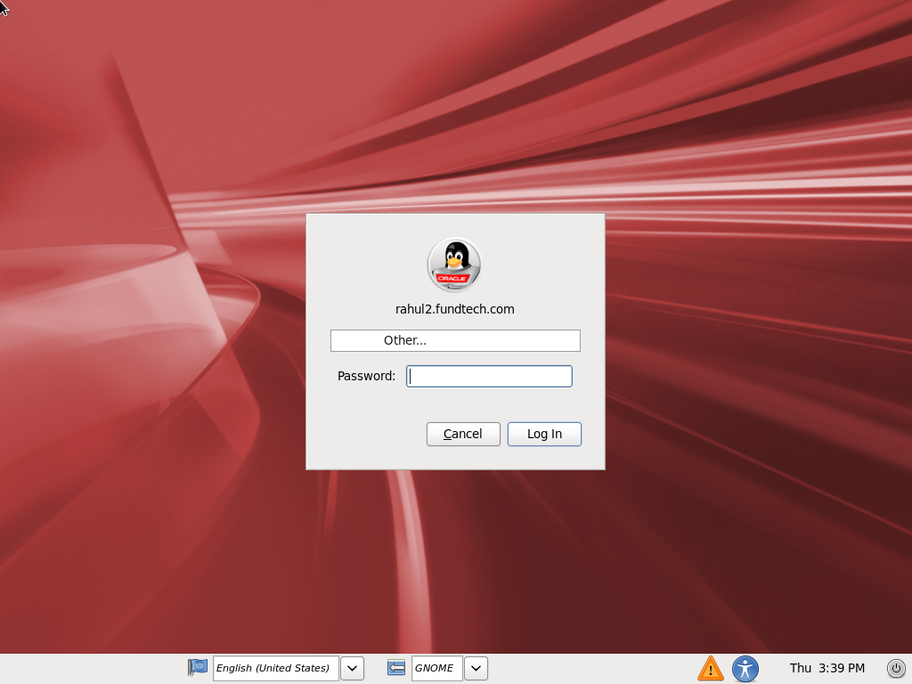

On popup message click on ‘Close’

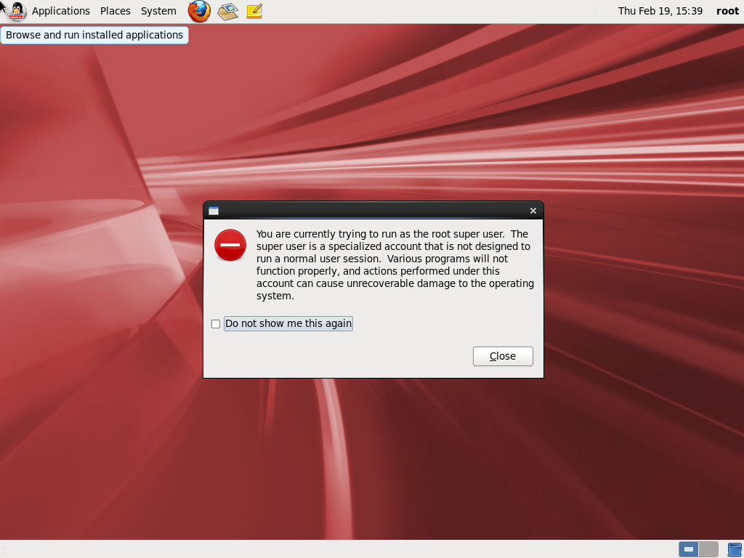

**Now your machine is ready for DB installation**